These test papers are copyright and must not be reproduced in any way.
©
This paper should be withdrawn after use in the examination or classroom and retained by the teacher.
Test papers may not be used for private tutoring in the year of publication.



PHYSICS

YEAR 11

2003

INSTRUCTIONS TO CANDIDATES

TIME: 2½ Hour Paper: MARKS: 160

Attempt questions 1 to 15 Section A
Attempt questions 1 to 6 Section B
Attempt question 1 Section C

TIME: 3 Hour Paper: MARKS: 200

Attempt ALL questions

STRUCTURE OF THE PAPER

Section | No. of  Questions | No. of questions  to be attempted | No. of marks  out of 200 | Proportion of  exam total
A: Short Answers | 15 | ALL | 60 | 30%
B: Problem Solving | 7 | ALL | 100 | 50%
C: Comprehension and  Interpretation | 2 | ALL | 40 | 20%

Note: Above refers to 3 hour paper. For less than 3 hours refer to front cover.

INSTRUCTIONS TO CANDIDATES

Write your answers in the spaces provided beneath each question. The value of each question (out of 200) is shown following each question.

The enclosed Physics: Formulae and Constants Sheet may be removed from the booklet and used as required.

Calculators satisfying conditions set by the Curriculum Council may be used to evaluate numerical answers.

Answers to questions involving calculations should be evaluated and given in decimal form. Quote the final answer to not more than four significant figures. Despite an incorrect final result, credit may be obtained for method and working, providing these are clearly and legibly set out.

Questions containing specific instructions to show working should be answered with a complete, logical, clear sequence of reasoning showing how the final answer was arrived at; correct answers which do not show working will not be awarded full marks.

Questions containing the instruction "Estimate" may give insufficient numerical data for their solution. Students should provide appropriate figures to enable an approximate solution to be obtained.
Section A: Short Answers

Marks allocated: 60 marks out of a total of 200 (30%)

Attempt ALL 15 questions in this section. Each question is worth 4 marks.
Answers are to be written in the space below or next to each question.

1 Accidents in Formula One races often result in the car splitting into many, many pieces and components fly in all directions at high velocities. Explain how the destruction of the car in this way supports the Law of Conservation of Momentum.
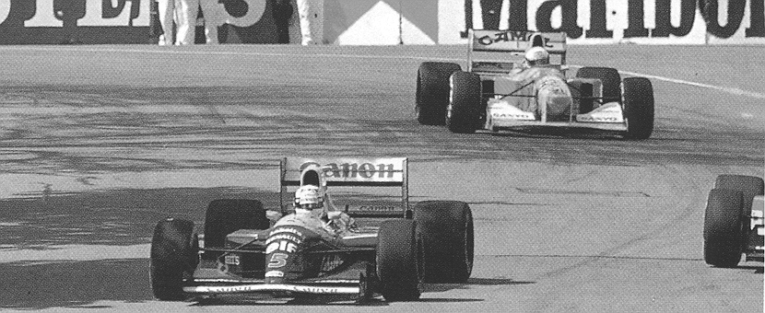

FORMULA ONE CAR

2 Steel barriers surrounding bridge pylons on the freeway have plastic ends bolted to them. See the photograph below. In terms of momentum and impulse explain the presence of the plastic ends.
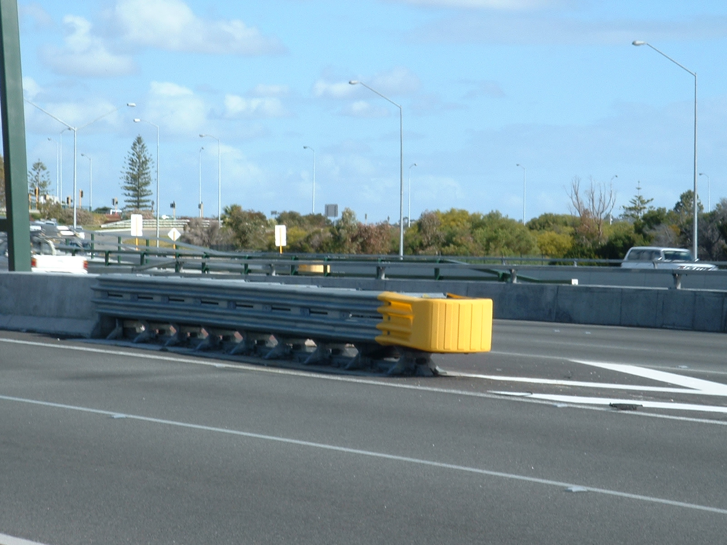
BARRIERS AROUND PYLONS

3 When survivors of ship wrecks are rescued after spending hours in near freezing water they are wrapped in shiny silver blankets. Why is this done?

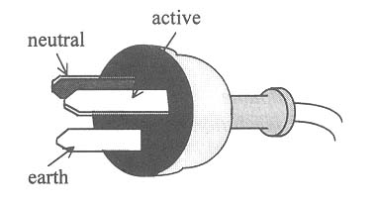
- The photograph opposite shows a common
THREE PIN PLUG
three pin plug used on domestic electrical
appliances. The three wires connected to
the plug have colors of brown, blue and
green/yellow respectively. Explain the
function of the green/yellow wire.

5 A teacher of year eleven told her students: “You don’t have to put a piece of iron in
an oven to heat it. Hit it with a hammer instead”. Explain the reasoning behind the
teacher’s statement.

6 Calculate the binding energy ( in eV ) for an atom of uranium-235.

7 A metal door handle feels colder to touch than a plastic door handle when the temperature of the surroundings is low. Explain.

- Nuclear power can be produced by a fission reaction. A typical fission reaction is shown below.

(a) If X represents the number of neutrons released in the single fission reaction then
what is the value of X?

(b) In what way do the neutrons produced by this reaction differ from the initial neutron
which is used to initiate the reaction?

(a) If you are holding a small pocket mirror and you cannot see your whole face do you:
(i) move the mirror closer so you can see your whole face.
(ii) move the mirror further away so you can see your whole face.
(iii) use a larger mirror so you can see your whole face.

(b) Explain why you chose your answer to (a) above.

A crane in a junk yard lifts a damaged car, which has a mass of 2 000 kg, to a height of 3.0 m.

above the ground. On the axes below sketch a graph to show how the weight of the car (y axis)

varies with the height it is lifted above the ground (x axis). Label the axes carefully.

11 It is difficult to see oncoming traffic if you are looking into the sun through a car
windscreen which is covered in dust. When the dust is cleaned from the windscreen you can see a lot better in the same situation. Explain why this is so.

- (a) Just before she serves a ball in a tennis match, Venus Williams throws the ball towards the
ground with an initial velocity of 5.0 m s⁻¹. If she releases the ball 0.8 m above the
ground, with what velocity does it hit the ground?

(b) Assuming the ball rebounds vertically at the same speed as it hit the ground, calculate the
highest point the ball could reach.

13 One way of determining whether a diamond is a fake or not is to subject the jewel to laser
treatment. This involves shining a laser onto the jewel and measuring angles of incidence and refraction. The diagram below shows how the incident laser beam is refracted by the jewel. Perform the necessary calculation to determine if the jewel is or is not a diamond.
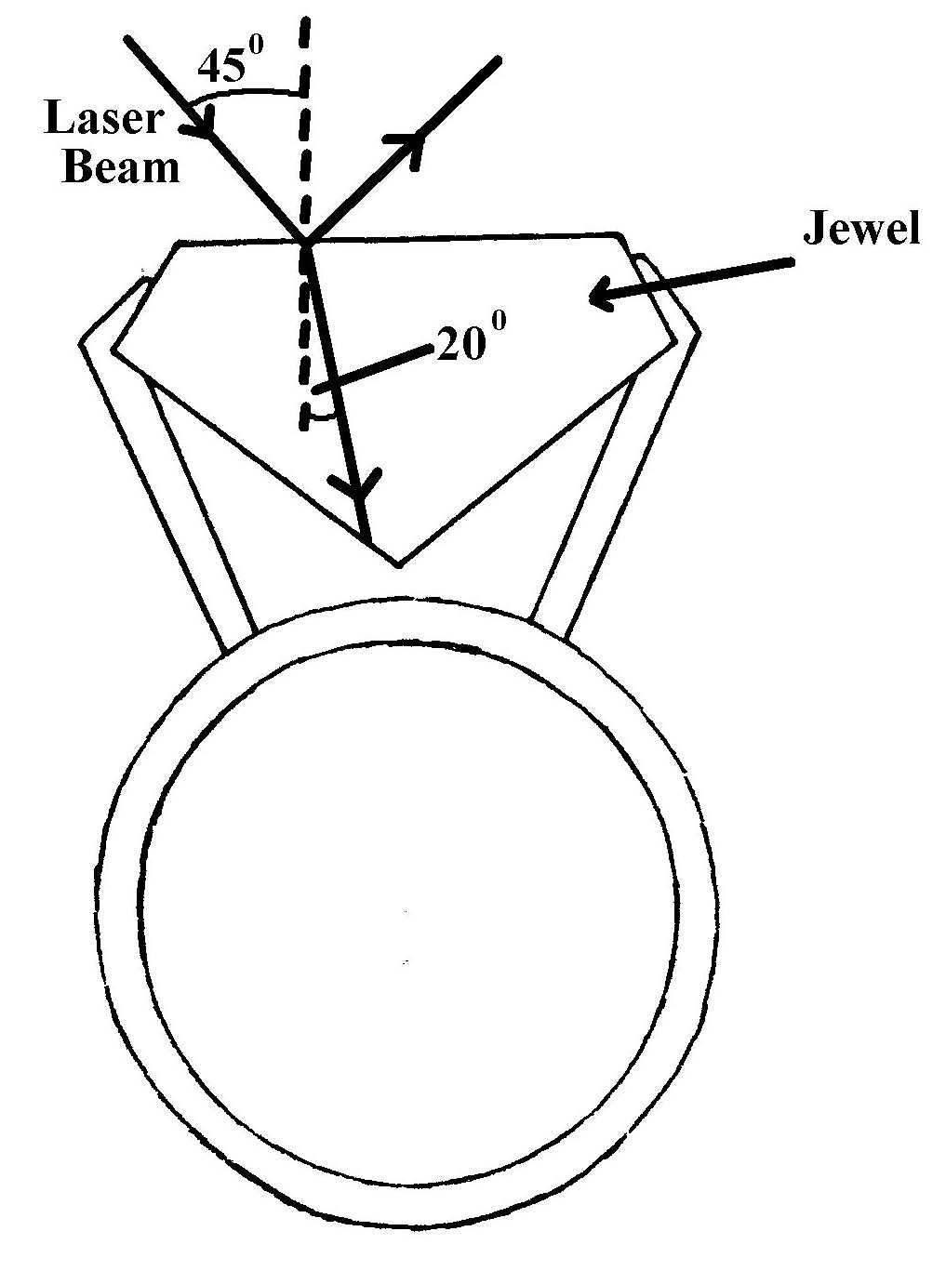

14 A drill bit is cooled by running cool water over it as it drills through a thick piece of steel. Why
is it necessary to have the water running over the drill bit and why is water used instead of oil to cool the drill bit?

- A resistor to be installed in an electrical appliance is tested to find out if it is an ohmic
resistor or not. After experimenting the test results were graphed. (see below)
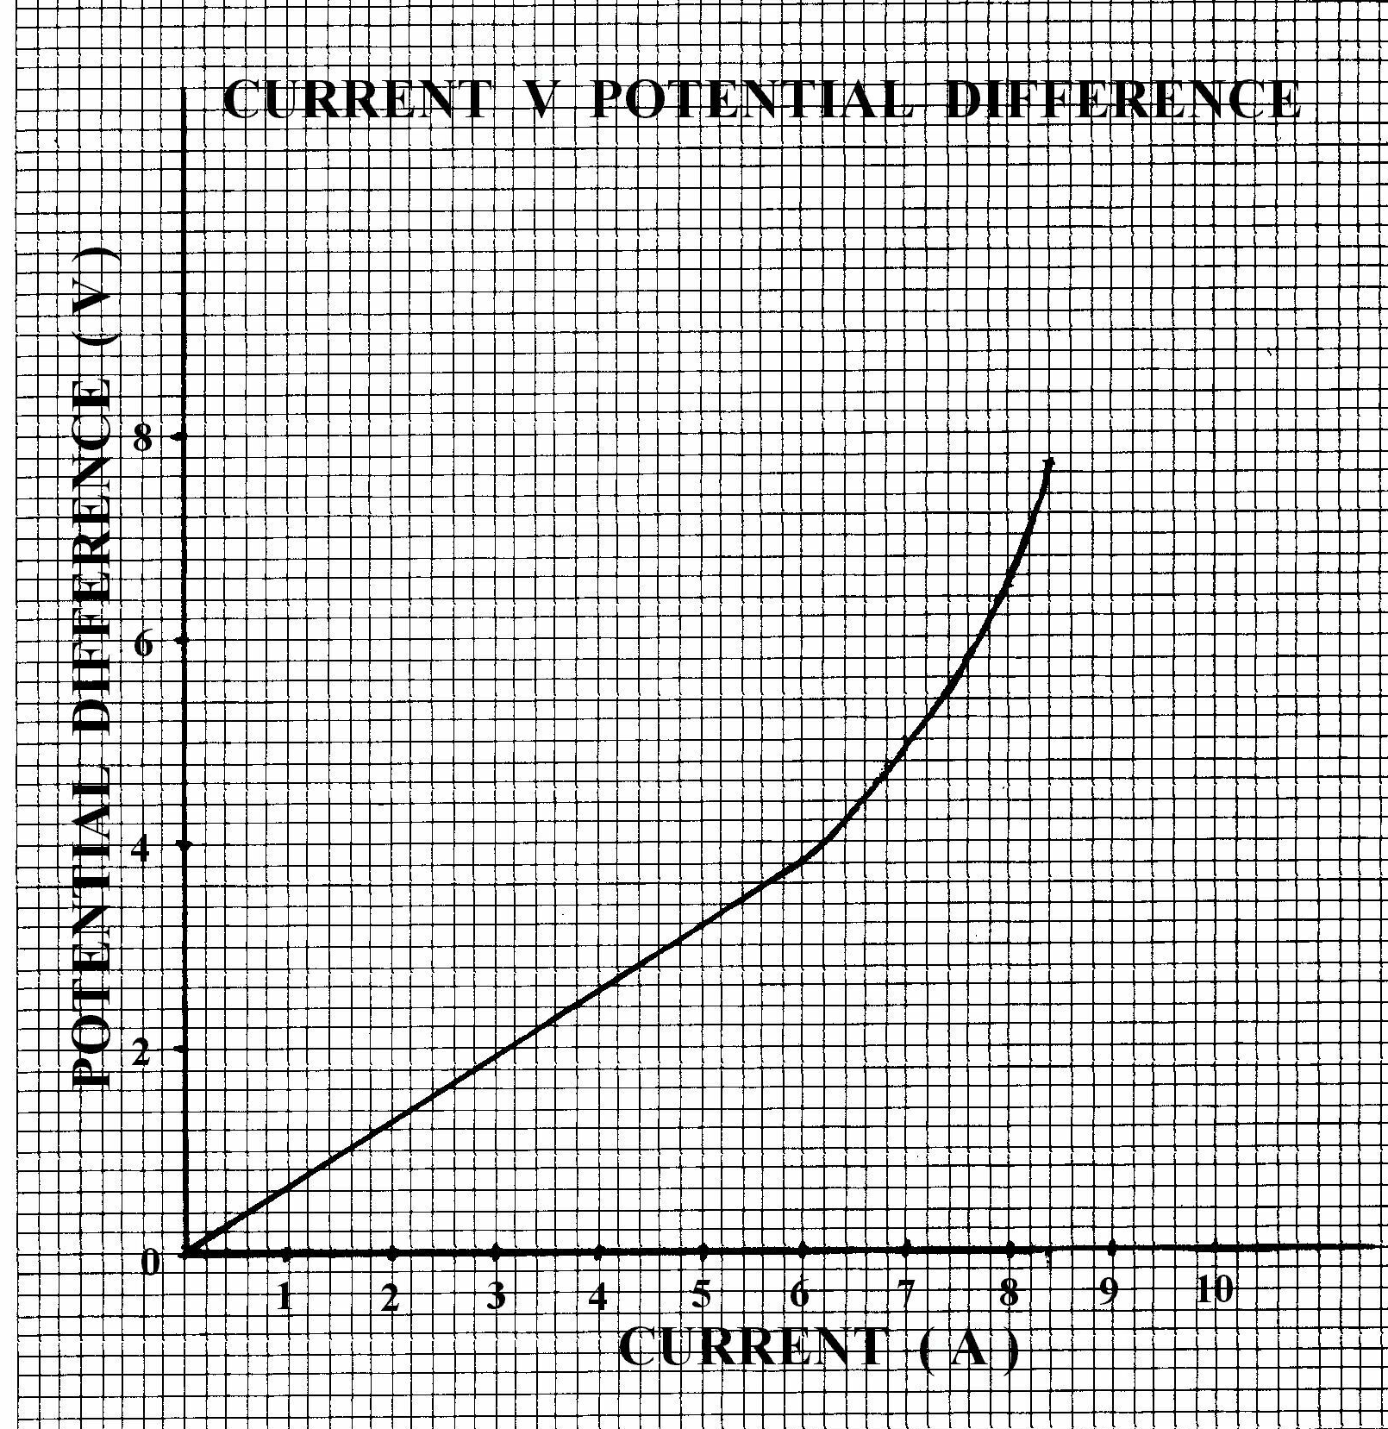
(a) What is the resistance of the resistor in the ohmic range?

(b) Does the resistor offer more or less resistance when it is non ohmic?

(c) Support your answer to (b) above with a calculation.
Section B: Problem Solving

Marks allotted: 100 marks out of a total of 200 (50%)

This section contains 7 questions.

You should answer: ALL of the questions 1, 2, 3, 4, 5, 6 and 7

Answer the questions in the spaces provided.

(14 marks)
(a) The average energy available from the sun in Perth is 300 W m⁻² over an 8.0 hour
period. If that quantity of energy is incident on a fresh water swimming pool which
measures 6.0 m x 3.0 m x 1.0 m deep, for 8.0 hours, then calculate the total
quantity of energy which falls on the pool. (3 marks)

(b) If the energy was distributed evenly throughout the water in the pool calculate the resulting change in temperature of the water. (assume no evaporation) (4 marks)

(c) If in a still pool only water in the top 10.0 cm was affected by the sun’s energy, calculate the difference in temperature between the top and bottom layers of the water. (assume no evaporation) (3 marks)

(d) In fact the energy from the sun will cause water at the surface of the pool to evaporate. If 20% of the energy from the sun was used to evaporate water what
mass of water at 20°C would evaporate in the 8.0 hour period?
(latent heat of vaporization of water at 20°C is 2.28 x 10 ⁶ J kg ^{–1}) (4 marks)

2 (16 marks)
A typical fission reaction in a reactor can be represented by:

(a) Calculate the energy released, in MeV, when one uranium nucleus undergoes fission
in this reaction. (4 marks)

(b) If the nuclear fuel which provides the power output in this nuclear reactor decreases
in mass at a rate of 5.5 x 10⁻⁶ kg per hour, what is the maximum possible power output of the reactor? (4 marks)

(c) Waste fuel from the reactor is monitored before being taken from the site and stored
permanently. During this time the radioactive count rate of the fuel is 200.0 Bq above the background level, which is 7.0 Bq.
The half life of the waste fuel is 6.0 x 10⁸ years.

(i) What is meant by the term “background count”? (2 marks)

(ii) How long will it take (approximately) for the activity level of the waste fuel to fall below the background count? (2 marks)

(d) The waste fuel is known to emit gamma radiation. If a 70 kg worker was to absorb
20 J of radioactive energy in the form of gamma radiation;

- What would be her absorbed dose? (2 marks)

(ii) What is her dose equivalent? (2 marks)

3 (15 marks)

A group of students set out to find the refractive index of violet light in perspex. They
obtained a semi circular block and directed white light through it so a spectrum was produced. The diagram illustrates what the group saw. The violet light just travels along the interface between the air and the perspex block.

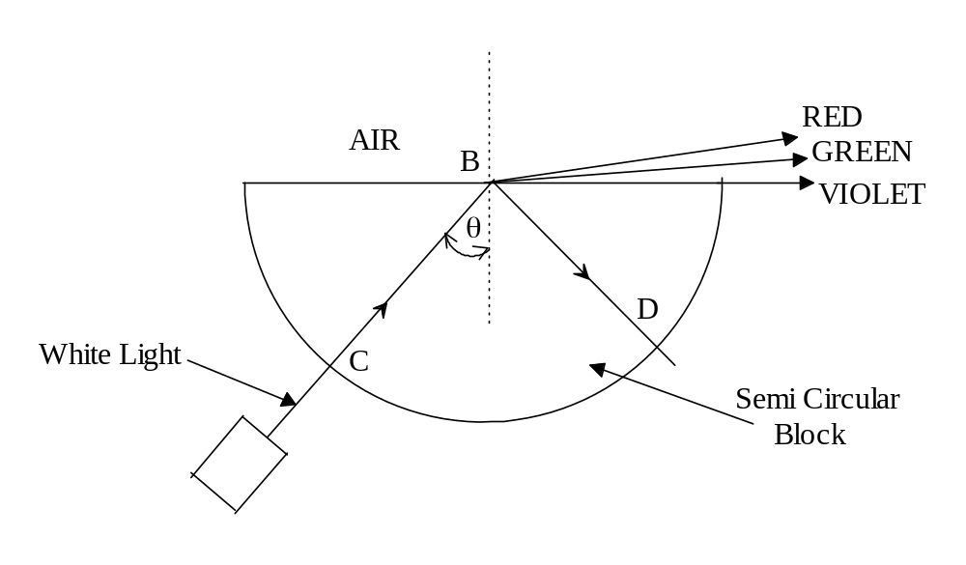
(a) Explain how the spectrum of colours arise. (2 marks)

(b) If the measured value of θ is 44.0º, what is the refractive index for violet light
in perspex? (3 marks)

(c) What is the value of the angle CBD? (1 mark)

(d) Explain how you arrived at your answer to (c) above. (2 marks)

(e) Explain why the ray of light BD is white and not coloured. (2 marks)

(f) Would you expect the refractive index of red light in perspex to be greater or
less than that of violet light? Explain using a sample calculation to support your
answer. (3 marks)

(g) In text books, tables of data containing absolute refractive indices for materials
quote RIs for yellow light not white light. Why is this so? (2 marks)

- (10 marks)
(a) A billycart and its rider (see diagram) have a
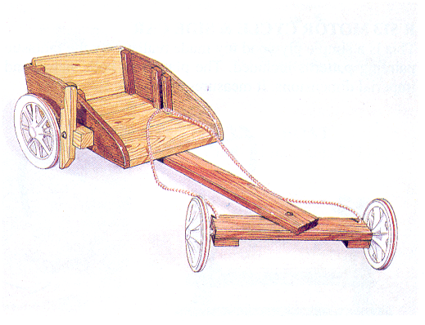
total a mass of 90.0 kg and is a starter in a
race. To get the billycart moving it is pushed by the rider’s assistant from rest with an average forward force of 70.0 N for the first 12.0 m on a level track.
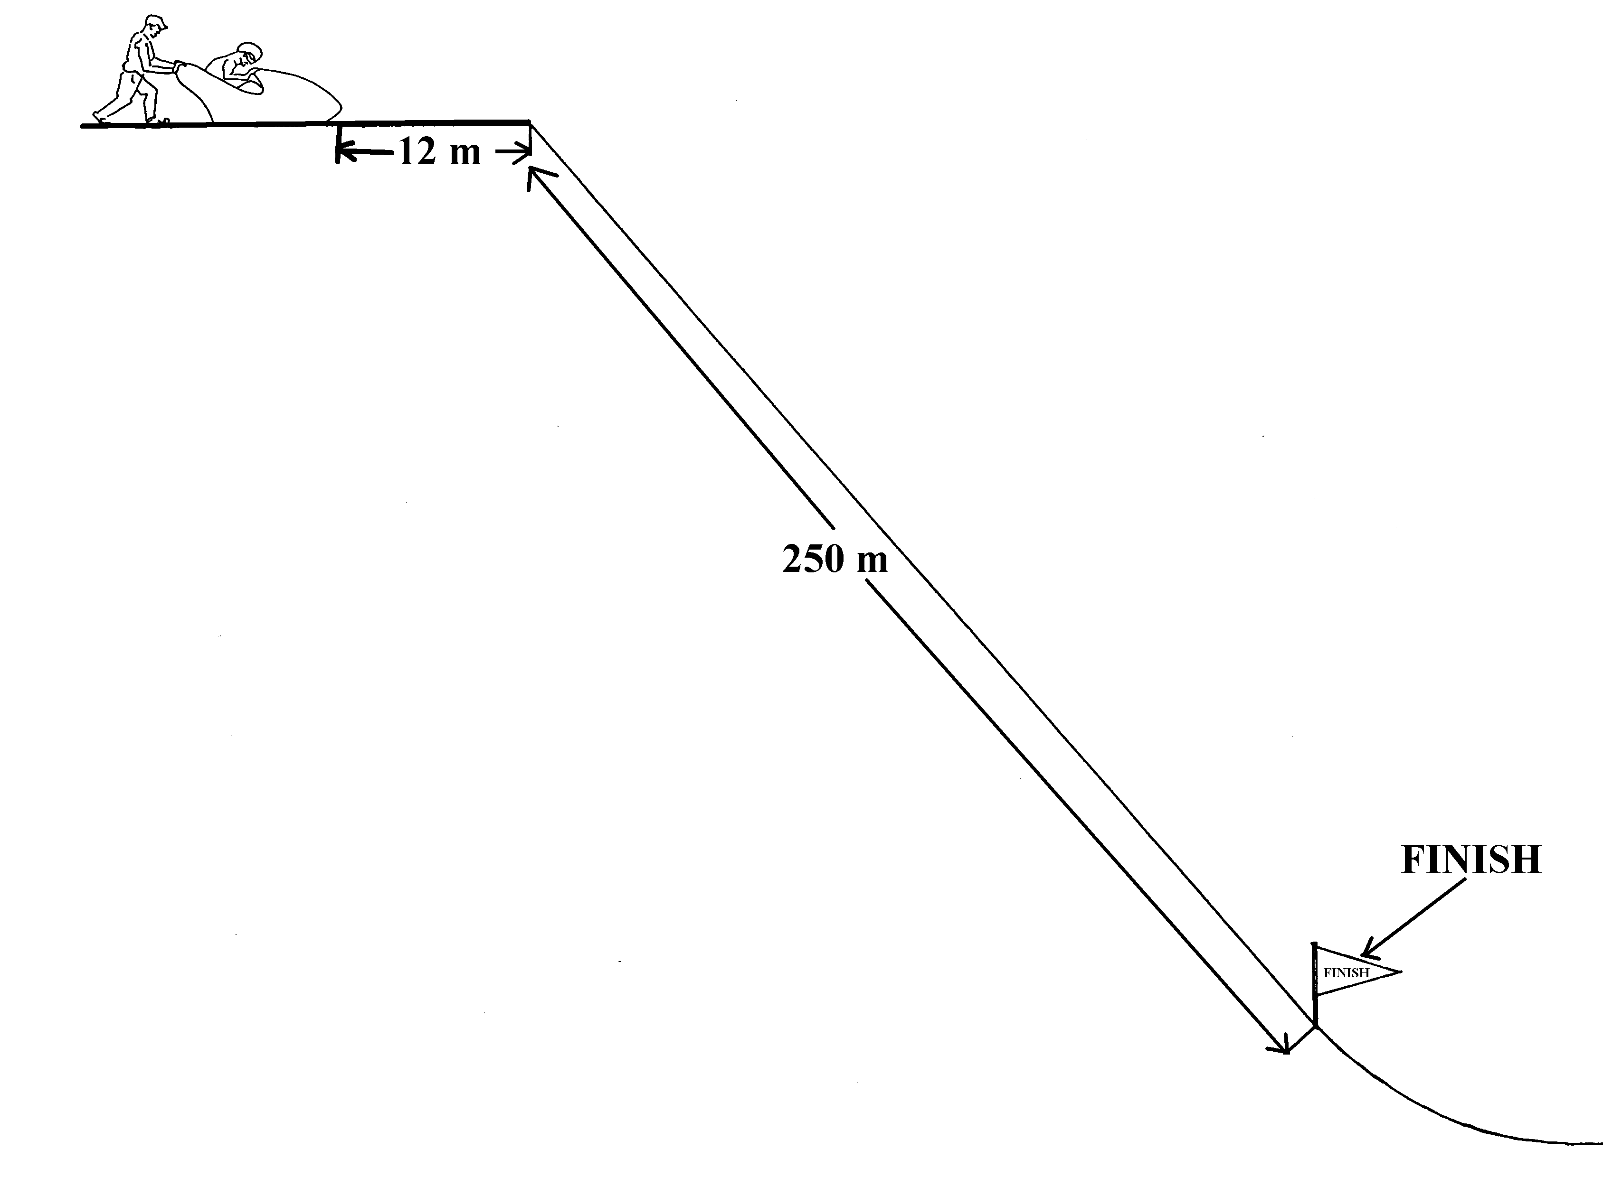
(i) What acceleration does the billycart and rider experience during the first 12.0 m
of the race. (1 mark)

(ii) What is the velocity of the billycart after it has traveled 12.0 m? (1 mark)

(iii) For what time was the billycart pushed? (1 mark)

(b) The billycart then travels down a steep hill for a further 50.0 m with an initial velocity
of 4.0 m s ^{– 1} and an average acceleration of 1.54 m s ^{– 2} . At the 50.0 m mark it
reaches its terminal velocity.

- What is the terminal velocity of the billycart? (2 marks)

- What causes the billycart to reach its terminal velocity? (1 mark)

(iii) How long did it take for the billycart to travel the 50.0 m? (1 mark)

(c) The billycart travels the remaining 200.0 m of the race at its terminal velocity.

What was the total time taken for the billycart to complete the race (including
the first 12.0 m) (1 mark)

(d) If the billycart takes 7.0 s to come to a standstill after crossing the finishing line:

- What average force was required to decelerate the billycart? (1 mark)

(ii) What was the change in momentum during the deceleration? (1 mark)

- (18 marks)
Two electrical appliances (M and N) are connected in parallel and measurements of voltage drop versus current are taken for a number values for voltage (V). The diagram below shows how the appliances are connected. One appliance obeys Ohm’s Law and the other doesn’t.
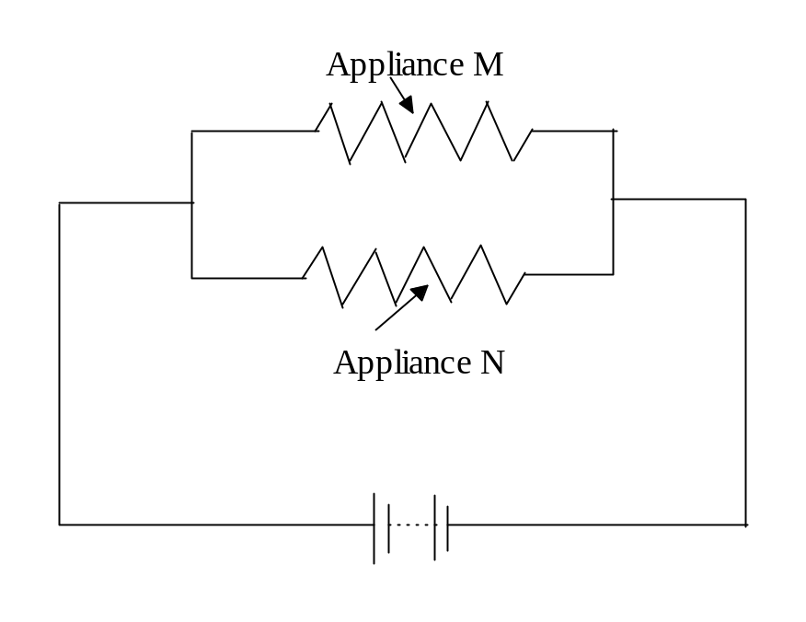
The results of the measurements are tabulated below.

Appliance M |  | Appliance N
Voltage Drop (V) | Current (A) | Voltage Drop (V) | Current (A)
0 | 0 | 0 | 0.0
5.0 | 1.0 | 2.0 | 1.0
10.0 | 2.0 | 5.0 | 2.0
15.0 | 3.0 | 10.0 | 3.0
20.0 | 4.0 | 15.0 | 3.5
25.0 | 5.0 | 20.0 | 4.0
30.0 | 6.0 | 25.0 | 4.0

(a) On the same set of axes graph the voltage drop (V) (x axis) versus current (A) (y axis) for both appliances. Label each line carefully. (4 marks)



(b) Which appliance obeys Ohm’s Law? Explain your answer. (3 marks)

(c) If the current through appliance M is 2.0 A what is the voltage drop across appliance N? (2 marks)
(d) What is the current through appliance N when the current through appliance M is
2.0 A? (3 marks

(e) Explain the general principle of electrical circuits which led you to provide your answers to (c) and (d) above (3 marks)

(f) When the voltage drop across the appliances is 25.0 V, what is the total current in the
circuit? (assume the battery has negligible resistance.) (3 marks)

6 (12 marks)
Following the failure of its engine a remote controlled model aeroplane of mass 4.2 kg
plummets towards the earth and hits the ground with a vertical velocity of 25.0 m s⁻¹.

(a) By how much does the Earth’s momentum change as a result of the aeroplane hitting
the Earth’s surface? (3 marks)

(b) How much energy is released when the aeroplane hits the Earth? (2 marks)

(c) By how much does the velocity of the Earth change due to the collision with the
aeroplane? (2 marks)

(d) If the aeroplane and the Earth were in contact for 0.75 s during the collision impact,
what is the force which results from the collision? (3 marks)

(e) If the aeroplane was traveling horizontally before its engine failed, estimate the
altitude it which it was flying at that time. (2 marks)

  - (15 marks)

A simple electrical circuit is set up to illustrate some principles of electricity. The circuit contains meters, resistors and a 12 volt battery of negligible resistance. The circuit is shown below.
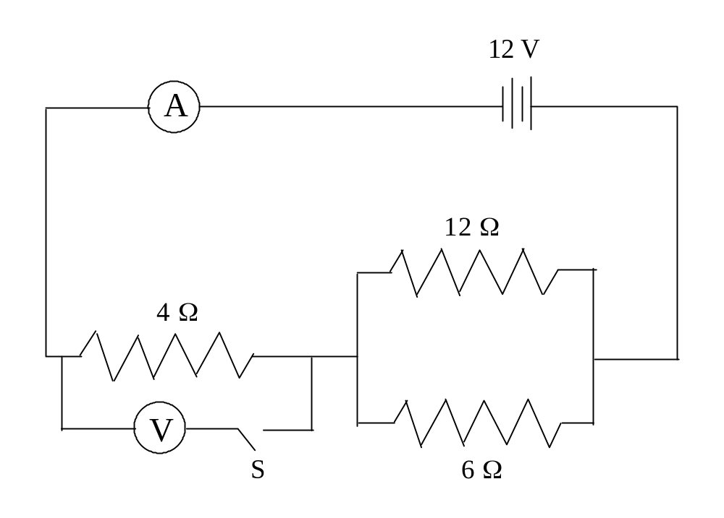
Answer these questions about the circuit.

(a) Calculate the total resistance in the circuit. (3 marks)

(b) What is the reading on the ammeter? (2 marks)

(c) What is the reading on the voltmeter when the switch (S) is

- open (2 marks)

- closed (2 marks)

(d) What is the current flowing through the 12 Ω resistor? (3 marks)

(e) Explain why closing the switch S should have no significant effect on the current
flowing through the circuit. (3 marks)

Section C: Comprehension and Interpretation

Marks allotted: 40 marks out of 200 (20%)

BOTH questions should be attempted. Each question is worth 20 marks.

Read each passage carefully and answer all of the questions at the end of each passage.
You are reminded of the need for clear and concise presentation of answers. Diagrams (sketches), equations and /or numerical results should be included as appropriate.

Question 1
Nuclear Energy
Paragraph 1
Matter in the nucleus of an atom is potentially the source of large quantities of energy. This is apparent even in the ordinary processes of radioactive decay. For instance in the decay of one atom of radium-226 the kinetic energy produced per nucleus is about 5 MeV.

Paragraph 2
This is provided at the expense of part of the rest mass of the original nucleus; there is a decrease of about 1 part in 40 000 in the rest mass of the particles, and this re-appears as the kinetic energy of the decay products, (and is then converted to internal energy of the material in which the particles are stopped). This may not sound very much. But suppose we have 1 kg of radium-226. The total energy ΔE converted from nuclear energy to internal energy when all the atoms of this have decayed is given by:

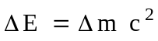

Paragraph 3
The total energy converted as the radium goes through its complete decay sequence is 8 times as
much - equivalent to the energy output of a 100 MW power station for 2 days. We do not notice the presence of this energy in the radium.

Paragraph 4
If energy is to be released in a nuclear reaction, the rest masses of the products of the reaction must be less than the rest mass of the original ingredients. The total number of nucleons cannot change in such a reaction, but the mass per nucleon decreases. See Fig 1.
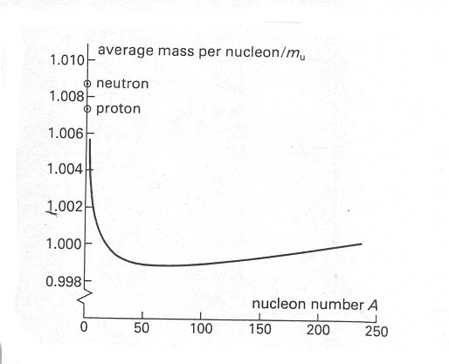

Figure 1

Paragraph 5
The nucleons in a compound nucleus are always less massive than these; and as we pass to larger mass numbers the mass per nucleon falls sharply at first, and then levels out. However, the important feature of the curve is the shallow minimum at about A = 60.
There are therefore two possible ways in which the nuclear energy of matter can be tapped.

Questions

1 Calculate the quantity of kinetic energy of the decay products produced when all the atoms
in 1.0 kg of radium - 226 have decayed. (para 2) (3 marks)

2 Estimate the quantity of energy produced by a 100 MW power station in 2 days. (para 3)
(3 marks)

3 Define rest mass of a particle. (para 2) (2 marks)

4 Why must the rest mass of the products of a nuclear reaction be less than the rest mass
of the original reactants? (para 4) (3 marks)

5 Why is the rest mass of the products of a nuclear reaction less than the original
particles? (para 4) (3 marks)

6 What element is represented on the graph (Fig 1) at A = 56? (2 marks)

7 What is the significance of the shallow minimum at about A = 56? ( Fig 1) (2 marks)

  - What are the two possible ways in which the nuclear energy of matter can be tapped?
(para 5) (2 marks)

Question 2
ACTIVE SOLAR THERMAL SYSTEMS
Paragraph 1
Active thermal systems are generally more complex than passive thermal systems. In addition to the solar collector and heat storage tank, active systems have a heat transfer control unit. This unit controls the flow of heat from the collector to the heat storage system.
The heat transfer control unit usually consists of one or more pumps or fans which control the flow of water, air or other fluids through the entire system.

Paragraph 2
Active thermal systems are usually designed to operate at high constant temperatures. Pumps or fans control the flow of fluid so that the temperature of the fluid leaving the collector is maintained at a constant temperature. Common uses for active thermal systems are in air-conditioning, electricity generation and providing heat for industrial processes.

Paragraph 3
The solar collectors used in active thermal systems can be concentrating or non- concentrating collectors. A concentrating solar collector concentrates the solar radiation onto a small area by the use of mirrors or lenses. Non-concentrating collectors are often referred to as flatplate collectors and are used in many industrial processes requiring hot water, such as washing bottles, where it is necessary to maintain the water at a certain temperature.

Paragraph 4
The simplest way to do this is by controlling the flow of water between the collector and the heat storage tank. In an active thermal system the flow of liquid is controlled by pumps. Whenever the temperature in the collector is greater than that at the bottom of the storage tank, the pumps are started. The pumps are stopped when the temperature in the collector is no longer higher than the storage tank temperature.
Two examples of non-concentrating active solar thermal systems are the solar pond and the solar air-conditioner.

Paragraph 5
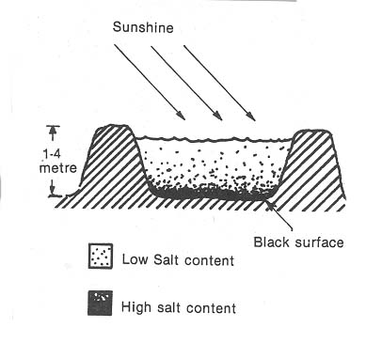
Solar Pond
A solar pond can be used to generate electricity and provide low-temperature heat for industry. The pond is a body of water between one and four metres in depth (see Figure 1). The surface area of the pond also affects the amount of solar radiation it can collect. A dark surface at the bottom of the pond increases the absorption of solar radiation.
The pond is filled in stages with water containing different amounts of salt. The bottom 'layer' contains the most salt and the top 'layer' is fresh water.
Figure 1

Paragraph 6
When solar radiation strikes the pond, most of it is absorbed by the pond. The temperature of the dense salt water layer near the bottom surface is higher than the fresh water layer near the surface of the pond. Heat stored by the salt water is piped to an evaporator. Liquid Freon in the evaporator is heated and changes into a gas (see Figure 2). The pressure generated by the gas spins a turbine and electricity is produced from the generator. Freon gas is then cooled and recycled to be used again.
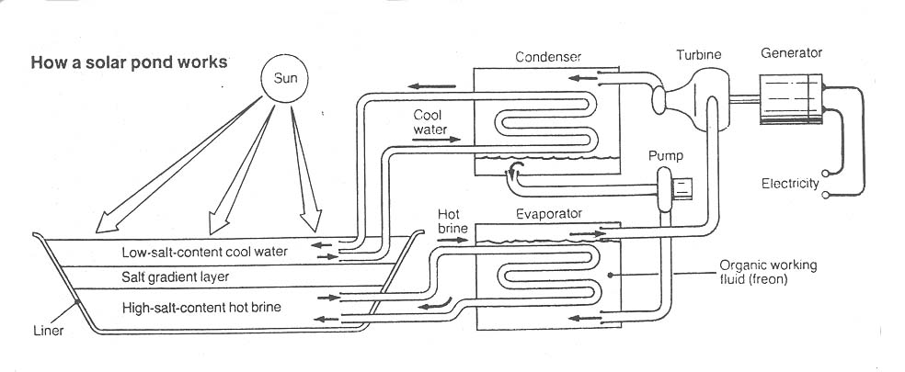

Figure 2

Paragraph 7
Solar Air-conditioning
Solar air-conditioners consist of a solar collector, heat exchangers, a cooling system and an absorbant and refrigerant to transfer heat through the system (see Figure 3). In the solar air-conditioner the refrigerant is water and the absorbant is a salt such as lithium bromide. Heat absorbed by the solar collector is transferred to the absorbant/refrigerant mixture. The heat separates the water from the lithium bromide.
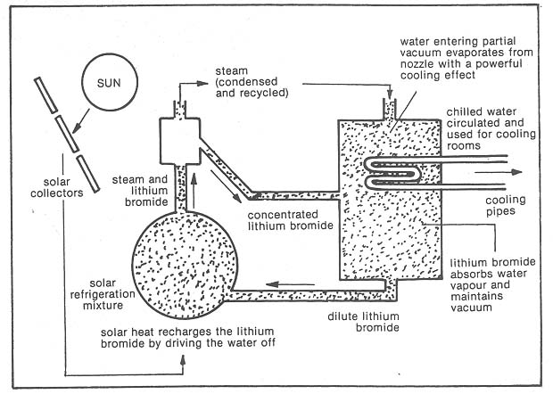

Figure 3

Water vapour is condensed, and then evaporated at low pressure. This evaporation produces the cooling effect. The vapour then combines with the lithium bromide and heat is released in this process. The cycle can continue and be repeated. During this process, heat-is absorbed from water running through the cooling pipes. This chilled water can then be used for cooling purposes.

Questions

  - Apart from their complexity, what is the essential difference between an active
thermal system and a passive thermal system? (para 1 and 2) (2 marks)

- How would the following help to concentrate the solar radiation? (para 3)
    - mirrors (2 marks)

    - lenses (2 marks)

- Why would you expect the temperature of the liquid at the top of the storage tank
to be higher than at the bottom? (para 4) (2 marks)

- How would the surface area of a solar pond affect the amount of solar radiation it
can collect? (para 5 ) (2 marks)

- Why is the bottom of the solar pond painted black? (para 5) (2 marks)

6 Why would the solar pond be less effective if the depth of the pond exceeded
about 4 metres? (para 5) (2 marks)

7 What is the purpose of having layers of water of different densities in the solar
pond? (para 5) (2 marks)

- What is the major limiting factor in locating solar ponds for production of
electricity? (para 5) (2 marks)

9 Refer to Fig 2 to answer this question. How does the water entering the partial
vacuum produce a powerful cooling effect? (3 marks)

END OF PAPER

ACKNOWLEDGEMENTS

SECTION C

Question 1: Nuclear Energy. Extract from Akril, Bennet and Millar (1979). Physics.
Published by Edward Arnold Publishing Ltd.

Question 2: Active Solar Thermal Systems.
Extract from Dekkers, O’Loughlin, Treagust, Vlahov (1985).
Energy From The Sun. Published by the Solar Education
Project.

